15009851

OPSC7311 Self Evaluation

Table of Contents

Assignment 1 Feedback 4

Assignment 2 Question 1 feedback 5

Assignment 2 Question 2 Feedback 6

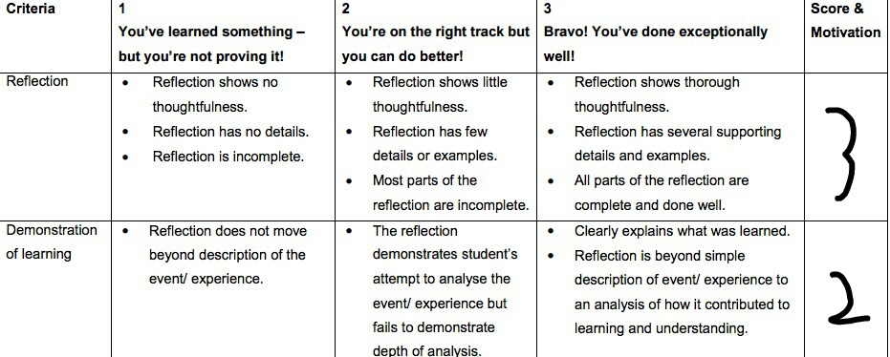

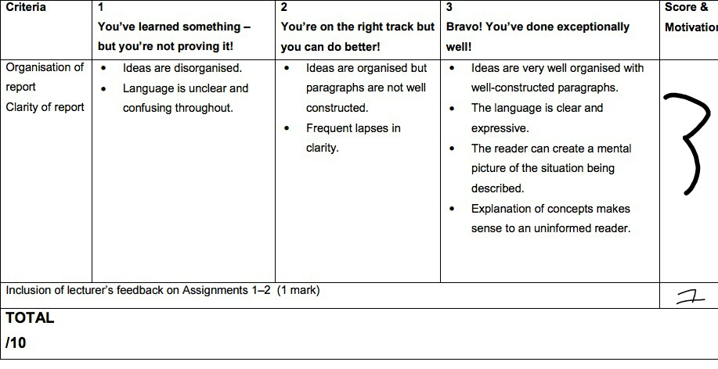

Total 9/10

On my first attempt for my assignments weren’t the best, didn’t have good designs and some functionality was missing from the first assignment. For the poe, I redid the designs for assignment 1 and question 1 of assignment 2. I added in a scroll view for assignment 1 for better displaying purposes.

Working with android studio has been a bit of a mission, with the computers on campus not working for the first month and bit with android studio we instantly went behind on schedule.

We lost class time, and rushed through everything without actually doing a lot of practice by ourselves. Mostly just looking at code in the book and typing it out. I had to do losts of my own learning and research to successfully finish this poe.

I fixed up most the feedback from the assignments.

I liked the problem solving which I used for Yahtzee to get the functions working.

# Assignment 1 Feedback

I covered all areas addressed.

# Assignment 2 Question 1 feedback

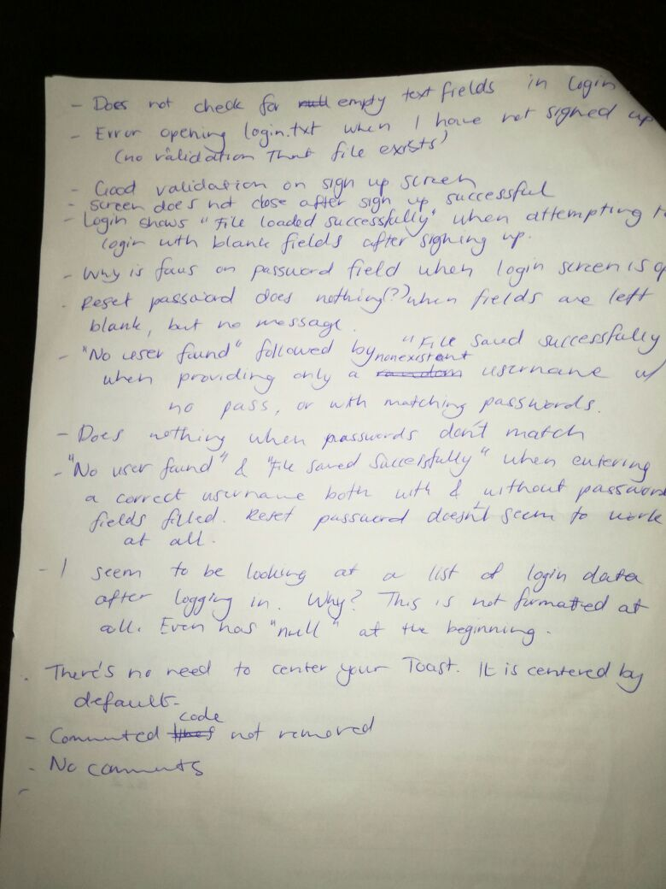

# Assignment 2 Question 2 Feedback

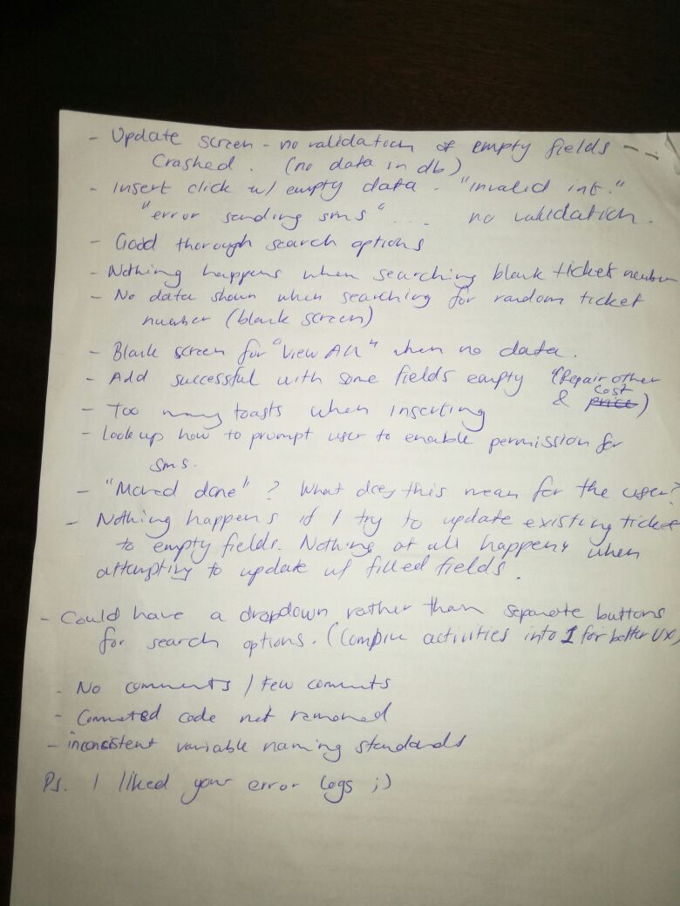

I addressed all the issues and corrected myself.

For question 2 I improved the design and kept the older design, I added in a navbar on all pages.